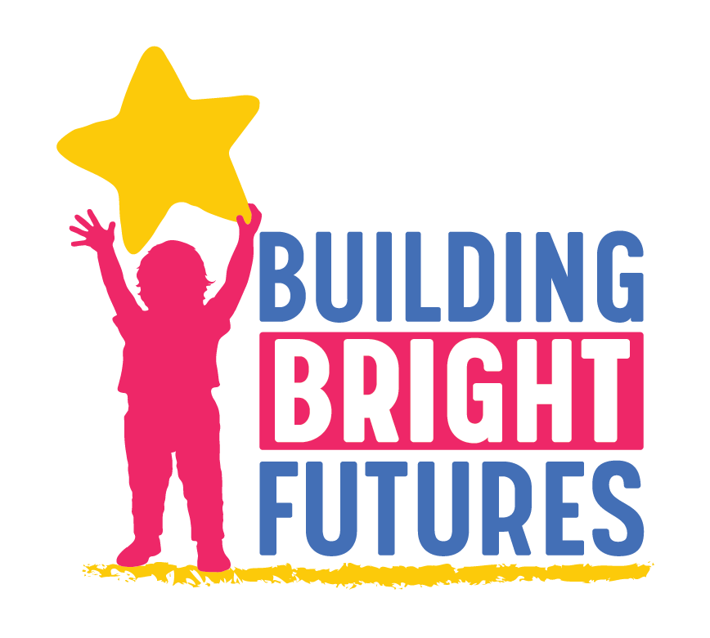
BBF Child Outcomes Accountability Team
December 17, 2020 | 9:00-10:30 am
Join Zoom Meeting: https://us02web.zoom.us/j/85664773532
One tap mobile +16465588656,,85664773532# US

The BBF Child Outcomes Accountability Team works to improve integration and coordination of early childhood public and private partners committed to the health and well-being of children and their families. The group will inform strategies and monitor progress to ensure that children are healthy, thriving and developmentally on track from the prenatal period to third grade by promoting and monitoring outcomes in the following domains: physical health, development and educational outcomes, mental health outcomes, and basic needs outcomes. Goal 1 also promotes the importance of prevention and early identification across the same domains.

Desired outcomes:
- Learn about the Family Engagement Assessment, successful family engagement models in the state and why family partnership and engagement is important
- Understand Vermont Early Childhood Action Plan -Goal 2 objectives and indicators
- Build relationships, understanding and trust across early childhood partners

In attendance - Amy Johnson/Parent Child Center Network, Amy Bolger/CDD, Becca Webb/PreK Coordinator, ynthia Greene/VT FEED, Karen Bielawski-Branch and Danielle Howes/CIS, Charlotte Safran/parent leader with VDH and UVMMC, CEmily Merrill/Parent leader and rep on SAC, Jen Fortman/Parent leader and co-chair of Families and Communities Committee, Janet Kilburn and Lauren Smith/VDH, Katy Davis/Hungerfree VT, Linda January/ECE Director, Mike Brancoforte/211, Pam McCarthy/Vermont Family Network, Renee Kelly/Head Start Collaboration Office, Tanya Lachapelle and Bev Boguet/Let’s Grow Kids, Beth Truzansky, Morgan Crossman and Dora Levinson/BBF

Time | Agenda Item
9:00 -  9:30 | 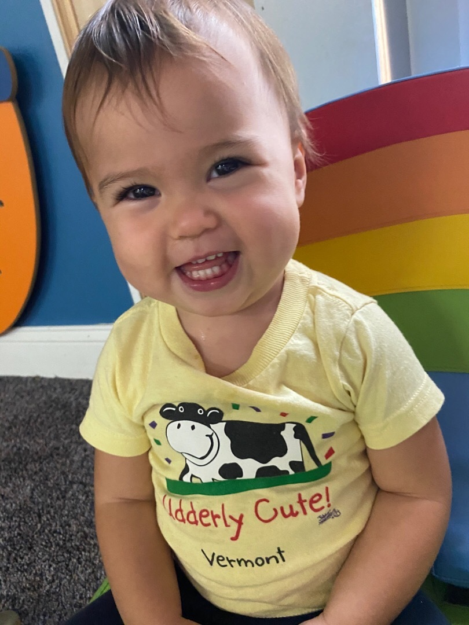  Welcome (Beth)  Last month we helped to visualize the life of a Vermont Child Born in 2026 as part of our committee’s work and exploration of Result 1 ‘All Children Have a Healthy Start’. The meeting’s opening mindfulness activity was Beth reading the visualization,  In the year 2026, a child is born to a family in Vermont. We will call her baby Mariah. Vermont is a state where all children and families are accepted for who they are and we support this child from the very start all the way through their development and education. This child thrives with the loving care of her parents and caregivers. Her family is safe and stable in their home and have food in their fridge today and on the horizon. Baby Mariah’s parents use paid family leave and home visiting to support the physical and mental health of both parents and baby. The family is connected to their diverse community and can access services, resources and support they need including high quality child care, a faith community, healthy food and jobs. Mariah grows into a toddler, preschooler and eventually transitions into the local elementary school. She is resilient to navigate even the difficult days she will face.  Mariah does not know there is a community holding her and her family through a seamless system of support. This is a system where all children have a healthy start. Where families and communities play a leading role in children’s well-being. Where families have access to high quality opportunities. And where the early childhood system is integrated, well resourced and data-informed. This is the future.  The group shared reflections on the visualization, the power of using a vision especially when time are hard and how we can use this shared vision to inform our work together.  Introduce yourself and reflect on this vision, how does family engagement improve baby Mariah’s life? What are ways you are involved in family engagement or family partnership?  - Tonya - Wants to read this every morning  - Becca - Coming together across systems to reduce fragmentation  - Cynthia - powerful that Mariah doesn’t know that she is supported by a community and system  - Linda January - How to engage families beyond dropoff and pickup - especially during this pandemic  - Danielle Howes, Part C Administrator. What struck me was the "now and in the future" [with regard to the food security]. So often we address immediate needs. The idea that families are supported and can see long term that they are 'safe and have what they need' is such a great vision.  - Jen Fortman - the goal that the child doesn’t know  - Pam - Wants Mariah to know that the community is there to support her - excited to be part of this group!  - Katy - Goal for all of us to know that there is support ‘out there’. None of this is operating from a place of scarcity  - Amy B. - can be shared far and wide - a way to stay focused on the child. Change to each and every instead of all  - Amy J. - a reminder of why we are here - not just meetings  - Renee - social work principal - we want to put ourselves out of a job by empowering families
9:30 -  10:10 | Families as partners- Role of family engagement in supporting children to thrive  - Beth presented VECAP Goal 2 ‘Families and communities play a leading role in children’s well-being’ with a focus on family and community resilience.  - Summary: Vermont’s families and communities need to be strong, resilient and have the capacity to identify and meet the needs of children. A priority within this goal is to advance policies, and practices that honor and are supportive of each family’s culture, strengths, structure, expertise, and preferences. Building a system that listens to the needs of families, and creates space at the table to make decisions together, are core to success. To achieve this goal, Vermont will work to create safe and stable home environments, economic stability, family friendly workplace policies, parent and family leadership, and communities with social and physical infrastructure to nurture resilient children and families.  Where do you see yourself in this work?  - Renee - I am so proud of how this goal evolved to be less practitioner-centric (we need to help families engage) and more focused on creating space to make decisions together!  - Emily Merrill - I can reflect on how my child's care providers have helped our family feel stable and safe so that we can spend our valuable time and energy parenting our children during those very important early years.  - Tonya - How can this committee map the system? With the goal to link and leverage all the pieces to see opportunities and gaps to the goal.  - Goal 2 aligns with levels 2 and 3 in our early childhood framework ecological model.  - Measuring impact in these areas is a bit challenging.  - For Strong families, intermediate indicators are  - Access to paid family leave  - % children with a trusted adult in their lives  - Use of strengthening families framework  - 5 year indicators are  - % of children who are flourishing  - % of Adults who are receiving social and emotional support  - DCF involvement, or absence of involvement  - For Strong Communities,  - intermediate indicators are  - Access to community based infrastructure such as libraries or parks  - Access to out of school time care and summer meals  - 5 year indicators are  - Population growth in the state,  - Population growth of of non-white children  - Representation in government, such as % Vermont legislators who are women or identify as BIPOC  - Representation in educators and caregivers  - The final outcome area for this goal is in family partnership, leadership and decision making.  - Identifying measures for this has been very challenging and has been an identified data gap. But we are working on that and just completed the first, hopefully of a regular surveying of families to track family engagement and partnership in the state.  - Today we have a panel who have been involved in this project to present the key findings, process and talk about the importance in family engagement.  - We have a rich group with us and based on our opening reflection, many are deeply invested in meaningful family engagement. Our hope is to build alignment and common language and outcome measures to build a stronger case to improve family engagement and leadership in the state.
Panel

- Panel of Family Engagement experts who are leaders on the BBF VECAP Families and Communities Committee, serving as family representatives, or in support of building a stronger family engagement ethic in Vermont. They will also present about the Family Engagement Assessment just completed by the committee.
  - Emily Merrill-parent representative on the State Advisory Council
  - Jen Fortman-parent co-chair of VECAP Families and Communities Committee
  - Charlotte Saffron-Coordinator of the Patient and Family-Centered Care program/UVMMC Children’s Hospital and the Family Partnerships Consultant/VDH
Prompts:
  - What is an example of successful family engagement?
  - Why is family partnership and engagement important?
  - What did we learn from the Family Engagement Assessment?
The group had a discussion about the survey data and reflections on opportunities to strengthen transitions and utilize resources from Head Start and investment by PreK and K teachers and CIS among other partners.
10:10 -  10:30 | Act Early Needs Assessment - What did we learn about strengths and opportunities for our early identification system?  Lauren Smith from VDH presented several slides with what we learned from this survey of partners about the EI system and distribution of Learn the Signs materials specifically. The results were affirming to many of our existing priorities. See the slides for more detail.
10:30 | Adjourn

Quick Links
About the Child Outcomes Accountability Team and archived meeting materials
2020 Vermont Early Childhood Action Plan

Upcoming Meeting Dates and Topics
January 28: Social Determinants of Health-
- 2020 How Are Vermont’s Children and Families Report - chapter review and discussion
- Aligning screening and early care and education systems -

February 25: Universal Developmental Screening (coordinate w HMG UDS group)
- Status and opportunities for Universal Developmental Screening
- Pilot ECE project
- Cultural humility in screening
