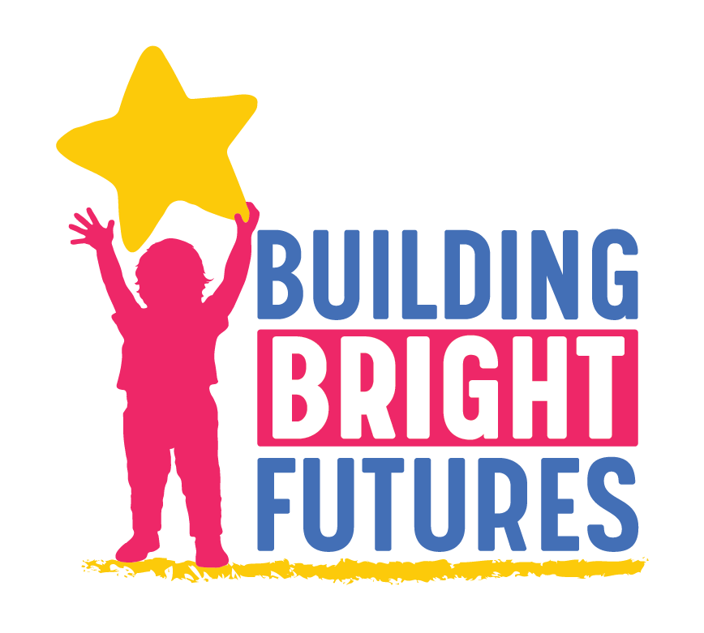
BBF Child Outcomes Accountability Team
November 19, 2020 | 9:00-10:30 am
Join Zoom Meeting: https://us02web.zoom.us/j/85664773532
One tap mobile +16465588656,,85664773532# US

The BBF Child Outcomes Accountability Team works to improve integration and coordination of early childhood public and private partners committed to the health and well-being of children and their families. The group will inform strategies and monitor progress to ensure that children are healthy, thriving and developmentally on track from the prenatal period to third grade by promoting and monitoring outcomes in the following domains: physical health, development and educational outcomes, mental health outcomes, and basic needs outcomes. Goal 1 also promotes the importance of prevention and early identification across the same domains.

Desired outcomes:
- Build a child persona for the committee to stay grounded in our work to strategize and monitor progress toward ‘All Children Have A Healthy Start’
- Explore 2020 Vermont Early Childhood Action Plan -Goal 1 indicators, objectives, and strategies
- Look at WIC data (one VCAP goal 1 indicators) and a Springfield area pilot effort to improve enrollment and child outcomes
- Build relationships, understanding and trust across early childhood partners

Attendees: Tanya Lachapelle, Dora Levinson, Cynthia Green, Breena Holmes, Katy Davis, Elizabeth Gilman, Auburn Watersong, Beverly Boget, Pam McCarthy, Amanda Biggs, Robin Stromgren, Renee Kelly, Amy Bolger, Beth Truzansky, Morgan Crossman, Dora Levinson, Jen Fortman

Time | Agenda Item | Notes
9:00 -  9:30 | Welcome  COVID check in: Given the surge in COVID cases in our state and recent socializing restrictions, what are your biggest concerns, priorities or emerging needs from our partners and families at this time? | - Amy Bolger: People are depleted after so many months of responding. There is a lot of talk about schools closing, but EC programs feel resigned to staying open. Honest information about data and these decisions.  - Pam McCarthy: Families are confused about how to make choices - what is the best? Working to build connections virtually again. Hope about vaccines and new administration.  - Amy Johnson: Going back to where we were in March - especially with regard to in person visiting and eyes on. “we've had the highest turnover at our agency in many years”. Staff are nervous about going into homes. Using evidence to inform decisions - schools as a successful example  - Renee Kelly: Questions are arising about long term outcomes from a lack of the services and supports that would have been in place. Professionals are burning out quickly. Local school control and the interplay with child care programs re remote learning. Surge in people reaching out about substance misuse, especially alcohol. Telehealth services have increased access since there is no transportation barrier.  - Jen Fortman: Families are looking for information about building immunity at home with vitamins - the challenges of runny noses etc.  - Breena Holmes: All hands on deck to keep schools open in Vermont. 98,000 school aged kids, 18,000 teachers and staff. 76 cases since September. We need to have a coordinated message that schools are safe and important for overall well-being and outcomes - not just pediatricians and the Governor. The child care community has been the heroes since March. Physiological response from constant cortisol doesn’t allow for us to take a step back - executive functioning etc. VDH has lots of information and messaging for families and professionals. 0 kids hospitalized in Vermont.  - Auburn Watersong: I would love to think about how we can get info out on dealing with burnout - for the workforce (which has been my wheelhouse) and for the families - which is info I’m sure all others on this call are focused on. Pandemic fatigue is too light of a term to describe what is going on. Continue to focus on strengths and building resilience  - Katy Davis: Lots of food programs exist now, but are ending in December. Existing programs (e.g. Veggie Van Go) will continue - need to promote these now so that once programs end, people are aware of resources  - Bev Boget: Hazard pay program for child care providers will go a long way toward feeling recognized  - Tonya Lachapelle: Burnout of EC educators and families  - Cynthia Greene: Connecting EC programs to food systems to help children and families be well nourished.  - Amanda Biggs: How can we help families feel supported and connected through the birthing centers?  Resources:  - Amy Johnson: so this is a great organization that puts out regular news letters and has done a ton on COVID and this topic specifically. I send the weekly newsletter to staff and they've found it helpful… https://ggsc.berkeley.edu/?_ga=2.198530927.1930237443.1605796352-45659029.1605796352  - Amy Bolger: https://elemental.medium.com/your-surge-capacity-is-depleted-it-s-why-you-feel-awful-de285d542f4c  - Breena Holmes: https://www.healthvermont.gov/sites/default/files/documents/pdf/COVID19-Transmission-Schools.pdf  - Auburn: preventing and addressing burnout during covid 19 - handout/document here: https://humanservices.vermont.gov/sites/ahsnew/files/Preventing%20and%20Address%20Burnout%20During%20COVID-19-Leaders%20PUBLIC%207.8.20.pdf  - For messaging on Resilience - please see the links in our Resilient Vermont newsletter here https://myemail.constantcontact.com/What-s-Happening-With-Resilience-Across-Vermont.html?soid=1134465821059&aid=KqYNyXjpK-o  - Mental Health First Aid - DCF Kinship care class - could it be adapted to serve a larger audience?  - Breena and Morgan will craft a message for Gov. Scott to share around EC programs
9:30 -  9:45 | Mindful Moment: Visualization of a Vermont child born in 2026  In the year 2026, a child is born to a family in Vermont. Who are they and what circle of supports exist for them to thrive? | In the year 2026, a child is born to a family in Vermont. We will call her baby Mariah. Vermont is a state where all children and families are accepted for who they are and we support this child from the very start all the way through their development and education. This child thrives with the loving care of her parents and caregivers. Her family is safe and stable in their home and have food in their fridge today and on the horizon. Baby Mariah’s parents use paid family leave and home visiting to support the physical and mental health of both parents and baby. The family is connected to their community and can access services, resources and support they need including child care, faith community, healthy food and jobs. Baby Mariah grows into a toddler, preschooler and eventually transitions into the local elementary school. The strong community, strong family support her resilience and ability to navigate even the difficult days she will face.  Baby Mariah does not know there is a community holding her and her family through a seamless system of support. This is a system where all children have a healthy start. Where families and communities play a leading role in children’s well-being. Where families have access to high quality opportunities. And where the early childhood system is integrated, well resourced and data-informed. This is the future.
9:45 -  10:00 | Explore 2020 Vermont Early Childhood Action Plan-Goal 1 indicators and WIC example | - Renee: Is having full enrollment a family priority or a practitioner priority?
10:10 -  10:30 | Regroup for a discussion on indicators and strategies  Where do you see yourself in this plan?  How do we use data and research to inform relationship building and integration? | - Cynthia: Opportunities for EC program setting and food security integration  - Renee: Recognizing the importance of comprehensive services - Amplify the work that Head Start and others have already done.  - Amy B.: Doing this work with an equity lens  - Bev: Glad to help in any way, perhaps connecting with some of the food and nutrition work may be a natural fit, and about how do we take some of the best practices from Head Start/SF/EMTSS around to the entire ECE field.
10:30 | Adjourn

Quick Links
About the Child Outcomes Accountability Team on the BBF Website
October 22 Recording and Slide Deck
2020 Vermont Early Childhood Action Plan (version approved by SAC, final graphics not yet included)

Upcoming Meeting Dates and Topics
December 17: Family engagement as a strategy to improve child outcomes
- 2020 Family Engagement Assessment Report
- Definitions and approach
- Screening and early identification

January 28: Social Determinants of Health
- 2020 How Are Vermont’s Children and Families Report - chapter review and discussion
- Economic stability and child outcomes (OEO, community safety, invite broader set of partners)

February 25: Universal Developmental Screening (coordinate w HMG UDS group)
- Status and opportunities for Universal Developmental Screening
- Pilot ECE project
- Cultural humility in screening

VECAP Goal 1- All Children Have A Healthy Start

Objective 1.1: Parents, caregivers and children have equitable access to comprehensive physical and mental health supports and services.

Strategy 1: Increase equitable access to maternal, prenatal and perinatal physical and
mental health services.
- Strengthen and use evidence-based home visiting to ensure each and every child
and family who need it have access.
- Advocate for investments to expand access to an array of home visiting services for families who have young children or are expecting a baby.

Strategy 2: Ensure prenatal to age eight healthcare services are comprehensive,
accessible, high quality, and culturally and linguistically responsive.
- Expand screening for perinatal mental health, food, and housing security screening efforts in medical and early care and learning settings .
- Connect families to information and community resources for pregnancy, child development, mental wellness, and parenting.
- Facilitate connections through Help Me Grow (HMG), Children’s Integrated
- Services and mental health agencies to community resources.

Strategy 3: Support programs, services and families to reduce the risk of chronic disease across the lifespan.
- Increase the integration of physical, behavioral and oral health for young children through care coordination services.
- Promote Vermont’s oral health guidelines across all early childhood sectors and
with families.
- Promote 60 minutes of daily physical activity across all early childhood sectors
and with families.
- Promote the importance of well-child visits, developmental screening and
vaccinations across all early childhood sectors and with families.

Objective 1.2: Families who are experiencing adversity have access to resources to meet their basic needs.

Strategy 1: Ensure that all children have access to adequate nutrition in home, in early
childhood programs, at school, after school and during the summer.
- Promote breastfeeding.
- Increase participation in food security and child nutrition programs.
- Invest in food security and child nutrition programming.
- Invest in and offer food security, nutrition, and food system professional
development.
- Increase community networking to support sustainable community-based farm to early childhood programs.

Strategy 2: Focus access to housing retention and assistance for families with young
children.
- Expand and focus housing subsidy for families with young children, starting with
families with children prenatal to 12 months of age who are experiencing
homelessness.
- Expand the supply of affordable housing, resources for housing retention and
rental assistance for families with children.

Objective 1.3: Each and every child and family has access to needed services and
resources to support optimal developmental and educational outcomes.

Strategy 1: Improve outcomes of Vermont’s vulnerable children 0-3 and their families by
ensuring equitable access to developmental and behavioral screening, early
identification, and interventions.

- Align developmental and social/emotional screening across environments – the
family home, medical home, child’s early learning environment, and community
settings – through use of Vermont’s Universal Developmental Screening Registry
to improve communication and coordination among providers and reduce
duplication.
- Invest and expand support for Children’s Integrated Services and early intervention under the Individuals with Disabilities Act (IDEA) Part C, to assure that each and every child who is eligible for early intervention and special education services is identified as early as possible.
- Align early identification, screening, and referral practices through program and cross-sector collaboration to streamline access for families and reduce duplication.
- Standardize developmental and behavioral screening and screening for social contributors of health across settings (mental health, physical health, childcare and education).
- Promote and expand the use of Help Me Grow’s centralized resource hub by
families and providers. Engage and empower families through information on
early child development, navigation of systems of care, and follow up care coordination to ensure young children get connected to needed resources and supports at an early age when the benefit is greatest.

Strategy 2: Create equitable access to early childhood and elementary education for each and every Vermont child birth through age 8. (See Goal 3)
- Expand flexible funding and staffing models to deliver early intervention and
special education services across settings (e.g. public schools, private child care, other settings).
- Ensure the early childhood workforce has the capacity to meet the needs of each
and every child across settings.
- Reduce barriers to access (e.g. connectivity, transportation, cost).
- Improve transitions between programs, services and education.

Strategy 3: Strengthen and use evidence-based early childhood and elementary
education programming to improve developmental and educational outcomes for
children 0-8. (See Goal 3)
- Standardize the use of Strengthening Families and Early Multi-tiered Systems of Support (Early MTSS) by EC programs across all Vermont regions.
- Promote and Integrate the efforts of Head Start and Early Head Start with other
developmental and educational programs.
- Increase access to Act 166, Universal Prekindergarten Education by expanding the number of hours alloted.
- Expand access to evidenced based literacy knowledge and instruction for all K-3 teachers school based mental and physical health services and clinics.

